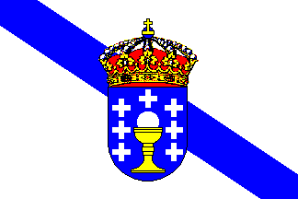

HELLO WE ARE FROM SPAIN
MY AUTONOMUS COMUNITI IS YCALLED IS GALICIA AND IT HAS FOUR PRVINCES. THE CAPITAL IS SANTIAGO DE COMPOSTELA THE MUNCI`PALITY WHERE .Y LIVE IS CALLED A CORUÑA
IN MY AUTOOMUS COMUNITY SPEAK ONE LAGUAGE SPAIN

